Microsoft Hololens 2 Head Up display

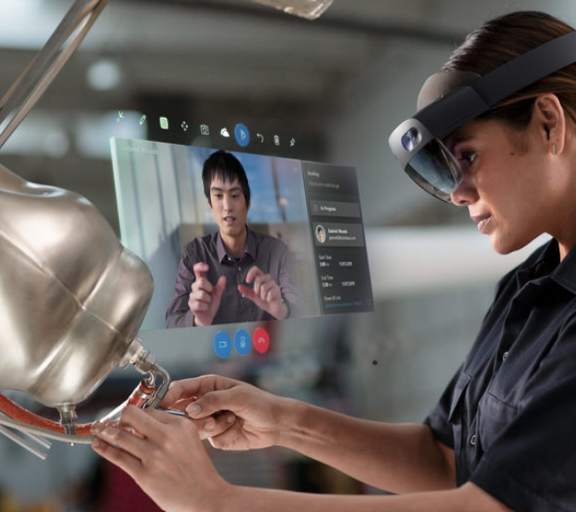

From research to production, nearly 90 percent of operations in the oil and gas industry consist of physical work, requiring skilled technicians and frontline employees. Operators Engineers can use HoloLens to construct and display 3D models, achieving a highly integrated display of virtual information and on-site scenarios for trainings conducted in mixed reality. The use of HoloLens will provide users virtual access to historical data of entire production environments, visual displays of gas reservoirs, wellbores, buried pipeline models, to ensure technicians can fully grasp the specific conditions of the allocated sites. This is critical in helping the workforce familiarize themselves with production equipment structure, process flow, and equipment operations of production sites at faster speeds.
“Unlike VR glasses, Microsoft HoloLens brings us a refreshing mixed reality experience. It breaks through the conventional human-computer interaction model and is not restricted by the environment. Its powerful SLAM (Simultaneous Localization and Mapping) function makes the combination of the virtual and physical worlds more feasible, enabling us to substantially improve our training and research

