TI 22 – 73. Technology Example – ENERGeo Seismic Interpretation
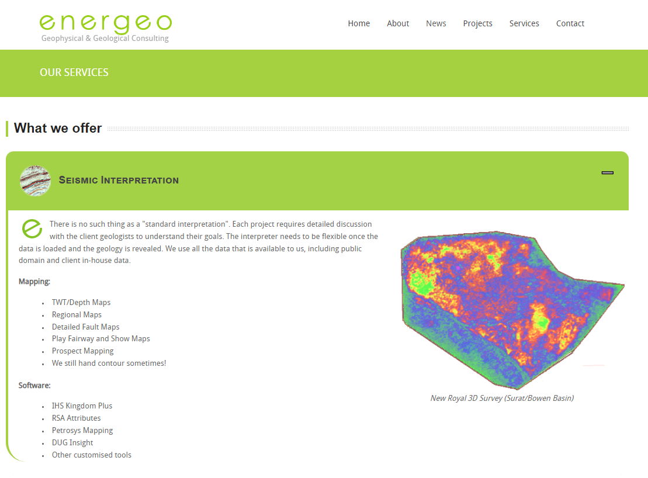

This is an example of Seismic Interpretation Technologies please follow link to the vendors website for more information
Link: energeo - Services

