TI 22 – 69. Technology Example – GDI Vision Automating remote visual inspection

Automating remote visual inspection
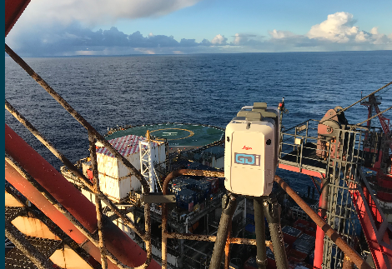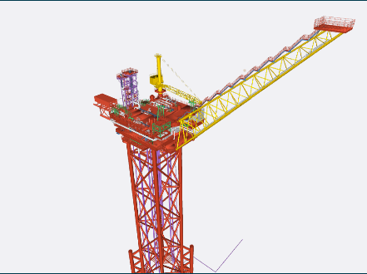

GDi provides clients with access to a web-based visual platform. Through this technology, we build a digital walkthrough of the asset to view the 360° HD photography.
This innovative web-based tool enhances operational and engineering functionality whilst delivering material cost benefits to our clients.

Step Change In Quality. Reduce Costs & Manpower.
GDi have developed a revolutionary visual inspection suite of tools that utilises the accurate inspection and engineering ready data we capture of your asset to rapidly detect and quantify defects. This system is deployed via GDi Vision and eliminates the need for traditional photography and descriptive text reporting.
The output is auditable, not subjective and can be overlaid over any number of inspections to view in detail where changes or degradation is taking place……….

The above technology example is an extract from the vendors website. For further details of this technology click the link below.
Link: GDi | Vision (globaldi.co.uk)

