TI 22 – 68. Technology Example – Accenture-Petrofac Connected worker
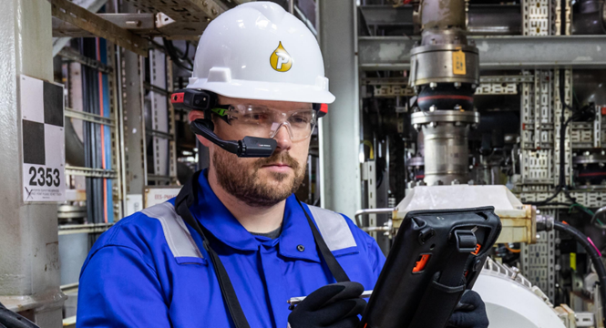
Better connections, better results Petrofac’s implementation of a connected worker solution is driving increased efficiency and safety. By enabling better coordination of onshore and offshore assets and improving knowledge transfer and upskilling, the solution is reducing the time needed to make decisions, ultimately speeding up operations while keeping workers secure. The solution is also helping to save crucial time by enabling inspections where data is captured handsfree, documented seamlessly and saved autonomously. This data is automatically transferred onshore for diagnostics where experts can provide remote assistance through picture-in-picture video calls to assist with repair and reassembly, significantly reducing the time to get to a resolution as well as possible down time. For SMEs, the ability to troubleshoot incidents and scope essential repairs has become much easier. Through interactive remote assistance, especially video calls that enable handsfree document sharing and live annotation, onshore SMEs can much more effectively guide offshore engineers through equipment repair and replacement. This collaboration saves the engineers time and effort in obtaining the information they need and allows them to run further real-time checks on equipment to prevent future failures. Finally, the ability to execute procedures through digital work instructions and to capture and record vital readings directly to the platform through external sensors allows supervisors to record, save and upload evidence of equipment prior to leaving the platform. This saves a significant amount of time during the handover process for the next supervisor. All of these improvements, made possible through the connected worker platform, have led to an increase in worker efficiency and effectiveness. All of this is placing Petrofac on a more secure platform, where it is becoming digitally enabled, forwardlooking, and able to thrive in a competitive energy industry

Link to Vendors website:
Digital Transformation Starts With Connected Workers | Accenture

