TI 22 – 65. Technology example – Aquaterra QUIKDECK Modular Deck Extension
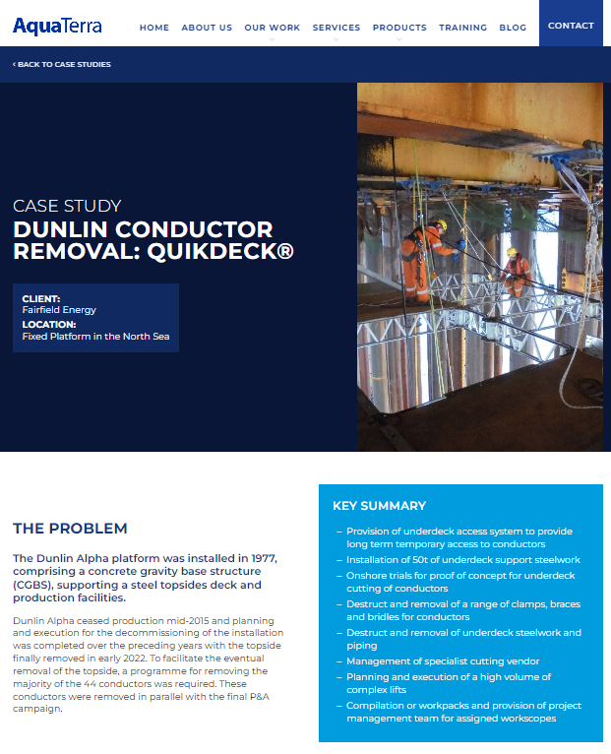
For further Information on this Technology Example click on the link below to go to the vendors website:
Case Study: Dunlin Conductor Removal: QuikDeck® - AquaTerra

