TI 22 – 63. Technology Example – INSITE Marine Ecology Studies
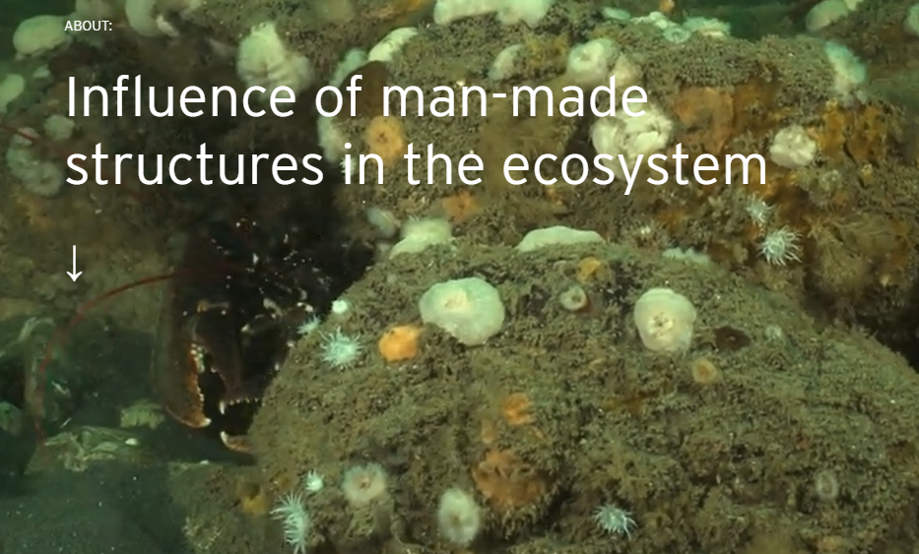
An estimated 30,000 km2 of the marine environment worldwide is host to manmade infrastructure and recent studies have shown that in addition to structural changes at these sites the abundance and diversity of sea-life is also modified.
After a successful foundation phase of research, the INSITE Programme is committed to developing a deeper understanding of the impact and role of man-made structures in the marine environment, specifically that of the North Sea.
16 Projects funded since 2014

Explore our community
INSITE projects have been undertaken across several European centres of excellence for marine science.
This extensive body of research has included data taken from across North Sea sites, the current second phase of research will continue until 2023.
- 8 Active Projects
- 8 Completed Projects
- 6 PhDs funding announced
For further information on this technology example the link below will take you to the Vendors website:
Link: About - INSITE North Sea

