TI 22 – 62. Technology Example – Allseas Pioneering Spirit Single lift vessel
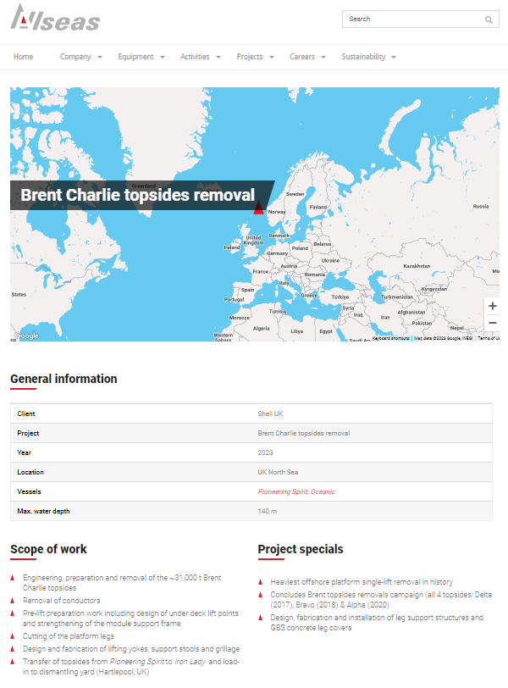
For further information on this technology please click the link below to go to the vendors web page.
Link: Brent Charlie topsides removal - Allseas

