TI-22 – 34. Technology Example - APTARA Lightweight Compact Tree
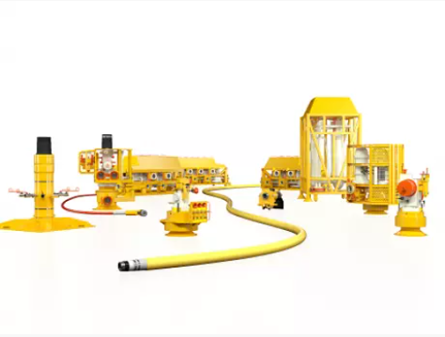

Flexible solutions that evolve throughout field life
The Baker Hughes Aptara™ family of TOTEX-lite products is born from our life-of-field approach. The Aptara name is derived from Latin for “adapt” or “fit”. It signifies the flexibility of this range of products to meet the evolving needs of operators from installation right through to end of field life. We have re-engineered the subsea system to make installation, production, and intervention simpler and more efficient—dramatically lowering total cost of ownership (TCO).

Next-generation technology
Our next-generation technology is smarter, simpler, and more efficient. It is designed ensure your subsea system is easier and more economic to install, operates smoothly, and has the flexibility to evolve over the life of your field.

Innovative life-of-field approach
The Aptara family of products combines an innovative approach with industry-first patented technologies to deliver subsea systems that have shorter lead times, lowering initial CAPEX and ensuring OPEX savings over the life of your field—making it a TOTEX-lite family. Our radically different life-of-field approach brings you a suite of products that is lightweight, compact and optimized to reduce TCO. The main building blocks of the Aptara subsea system are:
- Aptara lightweight compact tree
- Aptara modular compact manifold
- Aptara modular compact pump
- Aptara composite flexibles
- Aptara SFX wellhead solution
- Aptara subsea connection systems
- FLX360 multi-quick connection system
- HCCS-L lightweight horizontal clamp connection system

Aptara lightweight compact tree
The Aptara lightweight compact tree uses unique, patented tree caps that allow the tree to be configured to suit changing requirements—reducing cost and increasing value over the life of your field. These innovative caps also eliminate the need for independent modules and connections, reducing your costs further. Being 50% lighter than traditional trees, and with a considerably smaller footprint, Aptara lightweight compact trees can reduce your subsea system’s CAPEX and OPEX by up to 50% over the life of the field.

