TI 22 – 54. Technology Example – ABB “ESP Automated Control Systems”
ABB Web page snapshot:

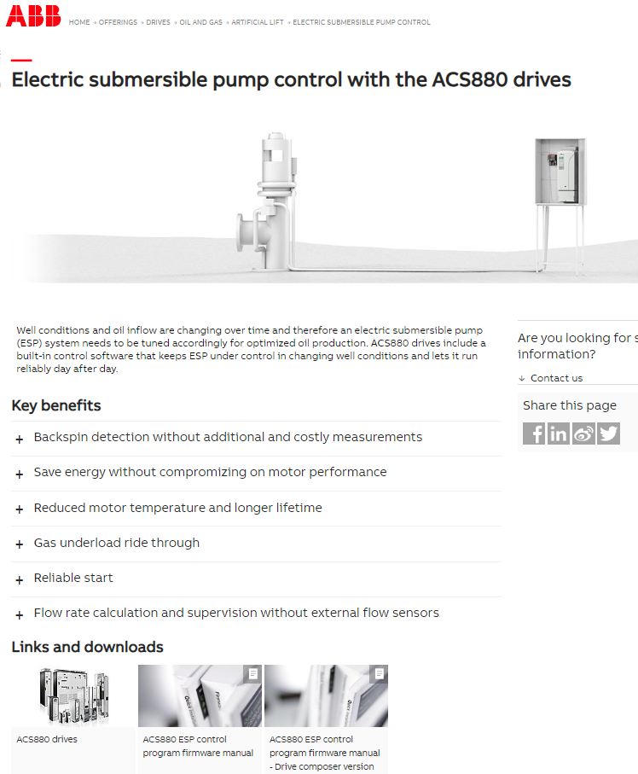
If you are interested in this example of ESP control Technology – here is a useful link to the vendors webpage for further information.
Link: Electric submersible pump control - Artificial lift (Oil and gas) | ABB

