TI 22 – 59. Technology Example – Ampelman W2W system

Ampelmann celebrates ten years of safe offshore transfers
August 28, 2017
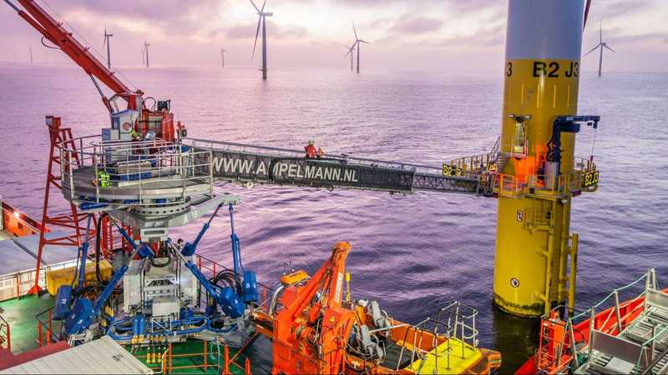
Press release
The global leader in offshore access solutions, Ampelmann, is celebrating its ten year anniversary. In just a decade, Ampelmann grew from a team of just four people to a 350 staff member organisation that services customers across the globe from offices in eight different countries. SPE Offshore Europe 2017 is one of the events where Ampelmann will reflect on its success with all attendees, while jointly looking forward towards a new decade of innovation, risk mitigation, cost control and efficiency.
With an impressive track record of over 3.6 million people transfers and 2.6 million kg of cargo transferred from ships to offshore structures in 200 individual projects, the industry leader with its Dutch headquarters has truly revolutionised offshore access.
Jan van der Tempel, the founder and CEO of Ampelmann, says ‘It is a thrilling and humbling experience to celebrate ten successful years with our customers and stakeholders at various events this year, including SPE Offshore Europe 2017. Our innovative approach has consistently been rewarded with the trust of our customers around the globe. We look forward to engaging with all kinds of stakeholders and to continue to innovate together.’
Ampelmann currently maintains a fleet of 60 operational systems used for transferring crews and cargo to offshore structures. These solutions are tailored to the needs of different market segments, sea states, cargo and crew loads, and are used by the key players in the global industry.
CEO Van der Tempel explains ‘In the current offshore climate, being able to transfer staff members to offshore structures safely, affordably and efficiently is more important than ever. We help our customers limit downtime and reduce their project costs. Our unique ‘plug and play’ system enables our gangways to be mobilised in less than eight hours. This helps our customers tremendously.’
Since its founding in 2007, Ampelmann experienced a rapid growth and invested in new production facilities in Rotterdam, the Netherlands, to keep up with demand. By 2011, the company’s innovative gangways were structurally used on a global scale, while the first international branch office was opened in Singapore in 2014.
To commemorate the ten year anniversary, Ampelmann published a whitepaper with a brief company history and more. It explains the ‘how and why’, and informs about existing and new developments in crew and cargo transfer solutions such as the A400, the L-type, the ‘Icemann’ N-type system created for Arctic operations and the A^{EP} (A-type Enhanced Performance). This whitepaper also informs about the Ampelmann S-type currently under development, which is being designed for use on medium and lightweight crew vessels with hull lengths of 50 metres and larger.
"In our short history, we became the global industry
Link to Vendors website – for further information on this technology see link below:
Link: Ready to use Walk to Work vessel (ampelmann.nl)

