TI 22 – 53. Technology Example – Aker Subsea Compression System

Subsea Compression Systems
Subsea compression has a long list of merits: it provides a better business case by cutting costs and increasing production, it is safer, being remotely operated, and has lower carbon footprint compared to other solutions.
Placing the compressor on the seabed spares the enormous cost of building and operating an offshore platform. Moving the compressor closer to the wellhead, increases production because of a lower pressure drop in the pipeline downstream, hence, the power required is lower compared to the alternatives. Subsea compression is also an ideal solution for deep waters and harsh climates.
The conventional subsea compression system includes a subsea separator, motor-compressor and pump units. They are used for high capacity applications, in compliance with the most stringent requirements and can tolerate the most challenging upset conditions.
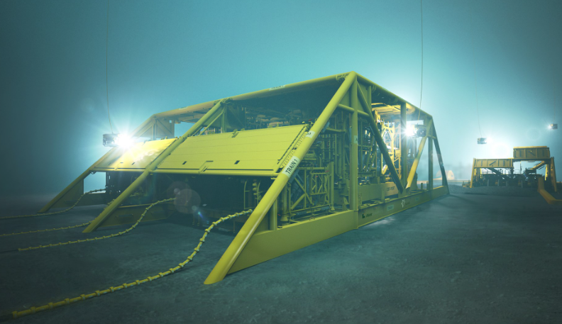

Link to Manufacturers Website
Subsea Compression Systems | Aker Solutions

