TI 22 – 44. Technology Example – CSUB Protection Structures
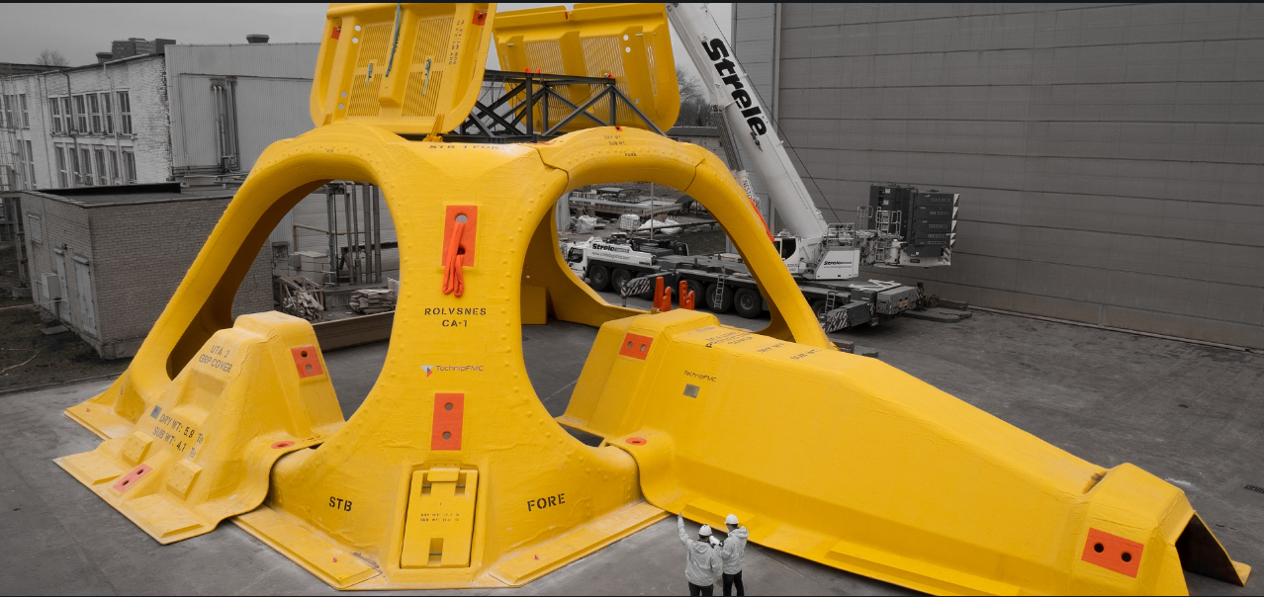

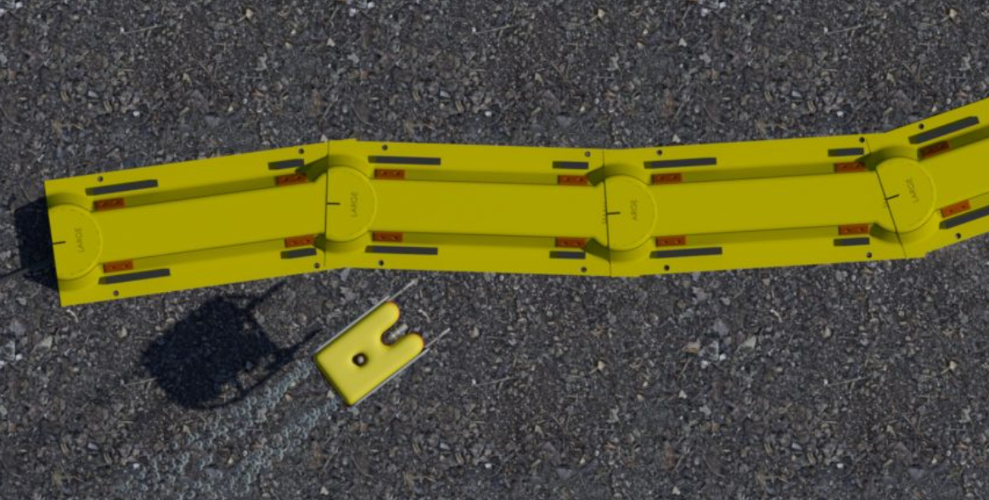
CSUB are manufacturers of GRP/Composite subsea protection structures, shown above are two example’s – wellhead protection and pipeline/umbilical protection, they also manufacture hatches, support structures, and are the manufacturers/suppliers for the protection structure for NOV’s Seabox subsea processing system

Link to CSUB website for full information:
CSUB Support Structures - CSUB

